DATA 430 Technical Report  Assignment 1 (a & b): Logistic Regression | Russell Larkin
Predicting COVID-19 with Logistic Regression
URL to dataset: https://www.kaggle.com/datasets/hemanthhari/symptoms-and-covid-presence?resource=download
Assignment 1a (due Week 2): you should complete the following sections ONLY:
- Overview (Problem Domain)
- Overview (Objective)
- Analysis (Exploratory Analysis)
Assignment 1b (due Week 3): all sections of this template should be completed. Modifications of the three sections submitted in Assignment 1a should be made based on feedback from the instructor.
This template should be used in conjunction with the assignment instructions. The size of the text area below will expand to the length of your response; the area should not be interpreted as a required or suggested length of response. Responses within the text area should be single spaced with Times New Roman 12pt font. The body of the document will likely be 6-9 pages, not including the Appendix; length may vary depending on specifics of the analysis and the dataset. As needed, APA format in-text citations should be included, along with a full references list at the end of the document.
Overview
Problem Domain: give some background and context about the problem domain (application area). For instance, if you are doing the analysis for predicting heart disease, provide some context about the disease and include some interesting statistics about it. Also, discuss how the method is relevant for the chosen problem.
COVID-19 emerged in late 2019 as a highly transmissible respiratory illness caused by the SARS-CoV-2 virus, with symptoms that could feel much like a cold, flu, or pneumonia. By June 1, 2024, the World Health Organization reported over 600 million confirmed cases and 1.2 million recorded deaths worldwide, with hospitals repeatedly strained during successive waves of infection (CDC, 2025). Asymptomatic and pre-symptomatic transmission, combined with variable sensitivity of PCR testing (including false negatives up to 30%), complicated timely diagnosis and containment.
My goal is to predict a binary outcome: whether a patient tests will positive or negative for COVID-19. This will be based on self-reported symptoms, exposure, and prior medical conditions. Logistic regression is a relevant and natural choice, because it directly models the log-odds of a positive test as a linear combination of predictors (symptom indicators, exposure factors, etc.) and it outputs interpretable probabilities between 0 and 1.
Logistic regress rests on a few key assumptions: that each predictor relates linearly to the log-odds of the outcome, that observations are independent of one another, and that no two predictors are perfect linear combinations (ie extreme multicollinearity is absent)..

Objective: clearly state the objective of the analysis in relation to the kind of algorithm you are employing. Use specific language as to what question(s) you are trying to answer using the specific analysis/modeling type.
My primary research question is:
“Will a public health screening questionnaire – utilizing a combination of symptoms, exposure risk factors, and reported pre-existing conditions – be able to effectively discriminate COVID-19 positives from negatives cases, with an emphasis on zeroizing false negatives?”

My goal will be to develop a logistic regression model that predicts whether an individual will test positive for COVID-19 (binary target) from self-reported symptoms, exposure risk factors, and pre-existing conditions. Logistic regression is best suited for this because it is designed to predict a yes/no outcome based on our variables, and it gives results we can easily understand.
I will (1) quantify feature distributions and relationships in an exploratory analysis, (2) engineer summary scores for symptom and exposure intensity, (3) tune regularization and class weighting to address imbalance, and (4) evaluate predictive performance via accuracy, precision/recall, F1, confusion matrix, and cross-validation.

Analysis
Exploratory Analysis: describe the data including the source, the collection method, and variables. Perform exploratory analysis. Also, select few key variables (including the target variable for supervised learning) and study their distributions using plots such as histograms, box plot, bar chart, etc.
Data source and collection method: I used a publicly available Kaggle dataset (H. Harikrishnan, 2020) of 5,434 individuals. Data included my target variable (COVID-19) and 18 binary features (after dropping two constant columns that added no value: Wearing Masks, Sanitization). I checked to make sure there was no missing data, null values, outliers, or invalid data types. The collection method seems to be a questionnaire. Features include eight symptom indicators, five exposure indicators, and five pre-existing conditions. The target “COVID-19” has four times as many positives (n = 4,383) as negatives (n = 1,051).
I created a heat map to explore the target against the features. The heatmap revealed that ‘Abroad travel’, ‘Attended Large Gathering’, and ‘Contact with COVID Patient’ were the highest exposure risk factors, and ‘Breathing Problem’, ‘Fever’, ‘Dry Cough’, and ‘Sore throat’ were the highest symptoms factors. I also computed pairwise correlations among all predictors (not just target vs. feature) and confirmed that no two features exceeded r|≈0.8. In doing so, the model is guarded against the variance‐inflation and coefficient‐instability issues that come with extreme multicollinearity.

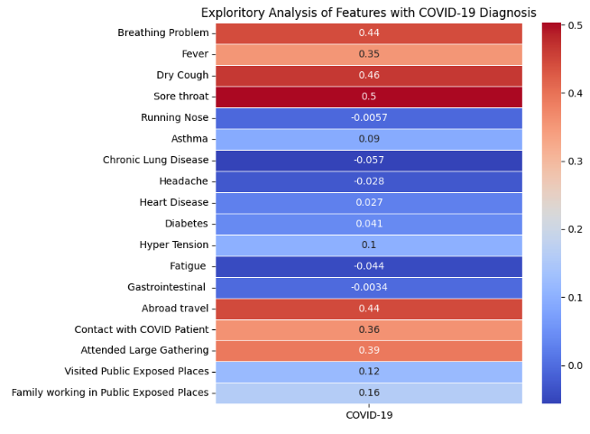Figure 1: Target correlation heatmap.

Symptom_Score (sum of breathing difficulty, fever, dry cough, sore throat) ranges 0–4 and shows most of our subjects cluster toward the high end of the symptom scale (~2000 with 3-4 symptoms). This corroborates the heat map by proving symptoms are a high predictor of COVID, and very few people were asymptomatic.
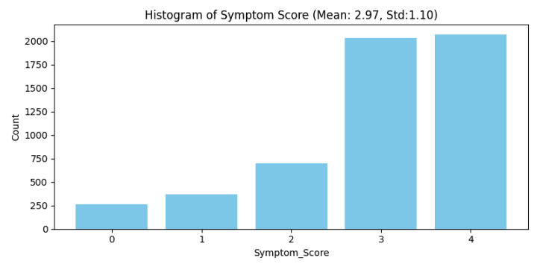
Figure 2: Histogram of Symptom_Score.

Exposure Score (sum of abroad travel, large gathering, contact with known case) boxplot shows that the distributions barely overlap. Negative COVID diagnosis without exposure is almost always ‘No, and positives results had usually two or three exposure events. That clear separation justifies exposure events as a key predictor in our model.

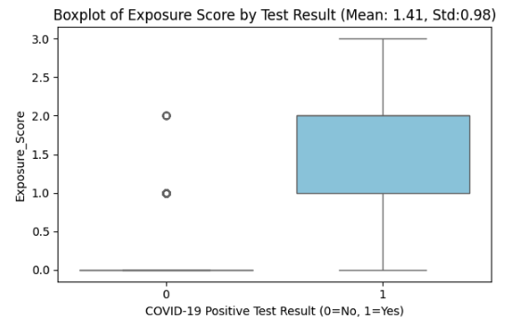
Figure 3: Boxplot of Exposure_Score by COVID diagnosis.

Preprocessing: armed with the exploratory analysis, perform the necessary preprocessing, both general and specific types appropriate for the modeling type being employed.
What I changed immediately:
- Removed two features that had only one unique value: ‘Wearing Masks’, and ‘Sanitization from Market’ for zero variance. These provided no information gain to the model.
- All yes and no values were converted to binary.
I created additional features:
- ‘Symptom_Score’ – the sum of the top symptoms risks (breathing problem, fever, dry cough, sore throat).
- ‘Exposure_Score’ – the sum of the top exposure risks (Abroad travel, Contact with COVID Patient, Attended Large Gathering)
- ‘Symptom_Exposure_Product’ = ‘Symptom_Score’ * ‘Exposure_Score’
I also explored removing some low-impact features (eg pre-existing conditions), but found that retaining the features yielded the best results.

Model Fitting: explain the key steps and activities you perform to fit the model. Experiment (as appropriate) with parameters tuning. This is key, what separates highly accurate model from a less accurate ones is the amount of performance tuning performed.
All code can be found in my Google Colab Notebook:
RLarkin Google Colab - COVID-19_Asgn1b

Initial model fitting involved:
- Splitting the dataset into 80/20, train/test.
- Using sklearn ‘LogisticRegression’ with ‘liblinear’ solver..

The model was initially trained using default parameters, then refined by:
- Adding penalty=’l1’
- Tuning regularization strength to 0.1.
- Adjusting the standard threshold manually from 0.5 down to 0.35.
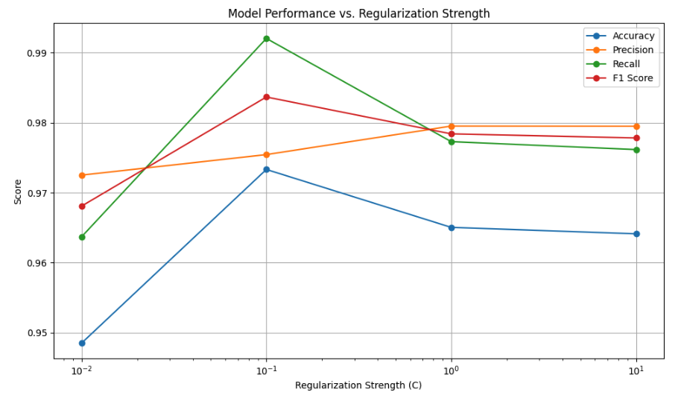
Figure 4: Model performance vs. regularization strength.

Results
Model Properties: explain the components of the fitted model and their characteristics. Leverage functions to summarize the model properties. Also, leverage visualization as required.
The logistic regression model assigns weights (coefficients) to each input feature, indicating its contribution to predicting the target outcome. The final model coefficients are shown in Figure 5. Positive coefficients increase log-odds of a positive result. .

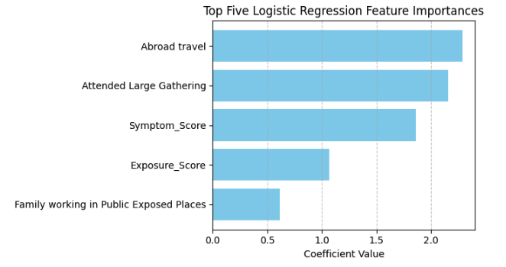
Figure 5: Top five logistic regression coefficients.

I discovered that regression models may assign a negative weight to a strongly correlated feature. A negative coefficient may arise when two predictors share information. The model down-weights one feature to prevent redundancy.

Output Interpretation: explain the result and interpret the final model output using terms that reflect the application area and in relation to the stated objective. This is where you check whether or not the stated objective is met.
The model successfully met its objective to predict whether a patient tests will positive or negative for COVID-19 based on reported symptoms, exposure, and pre-existing conditions. The most predictive features were well-aligned with public health knowledge regarding symptoms and exposure events. Moreover, engineered features like Symptom_Count and Exposure_Score provided interpretability and allowed the model to generalize patterns across related variables.

The logistic regression output indicated high confidence in the positive class. The model predicted only 0 false negatives, a critical factor in a public health screening tool during a global pandemic.

Evaluation: employ appropriate metrics to quantitatively evaluate the performance of the fitted model. For supervised classification, this includes simple accuracy, precision & recall (or sensitivity & specificity), all of which can be generated from a confusion matrix, or ROC.
Model performance was evaluated using multiple classification metrics. Results with:
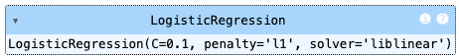

Accuracy: 96%
Precision (COVID+): 95%
Recall (COVID+): 100%
F1 Score (COVID+): 98%
Log Loss: 0.0915

I chose the final C = 0.1 based on 5-fold cross validation maximizing recall. I used the liblinear solver because it reliable handled L1 penalities in the moderately sized, binary dataset. The model achieved a mean recall of 95%, with scores ranging from approximately 0.89 to 1.0 across the folds. This reflected sensitivity to data splits and confirmed that the model consistently maintains strong recall.

The confusion matrix showed:
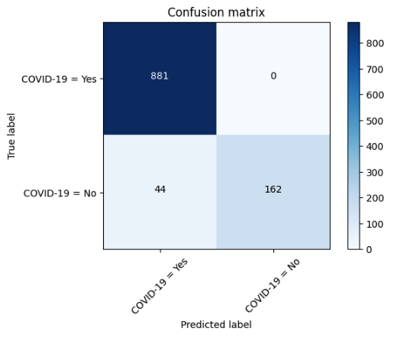
Figure 6: Confusion matrix.

I believe this level of recall is required for screening purposes during a pandemic where missing a positive case would be more serious than a false alarm. In addition, the log loss (0.0915) indicated well-calibrated predicted probabilities. Feature importance and visualizations further support the model.

Conclusion
Summary: highlight the main findings in relation to the stated objective. You don’t need to discuss the details of the analysis and the model such as accuracy here, just focus on the key findings.
The logistic regression model—built on binary symptom and exposure data—achieved 96% accuracy, with 100% recall and 95% precision on COVID positive cases, leading to an F1 score of 0.98. These results suggest the model is highly suitable for COVID-19 screening where recall is the top priority.
The key predictors were as expected: symptoms and exposure. This closely reflects historically known risk factors. Feature engineering of these known factors improved performance.
I was surprised that removing the pre-existing conditions reduced the accuracy of the model. I assumed this would have had an effect on the amount of deaths, but not the number of diagnoses of COVID-19. Testing the model by adding, removing, and engineering features was essential.

Limitations & Improvement areas: discuss the limitations of the analysis and identify potential improvement areas for future work. This could be related to the data, algorithm, or a combination of the two.
I believe the models limitations were as follows:
- All input features are binary, which limits detail – how dry was the cough, how sore was the throat, were you at a gathering outdoors or indoors, etc.
- Logistic regression assumes linear relationships and may not capture complex interactions.

Future improvements could include:
- Exploring additional interaction terms or nonlinear transformations (ie spline adjustments)within the logistic regression framework to capture any subtle nonlinear effects.
- Incorporating more/new data for broader generalization.

The model predicted a higher number of patients as COVID-positive who were actually negative. These individuals would have been quarantined as a precaution to prevent potential spread. While this results in more false positives, it aligns with public health priorities by minimizing the risk of missed infections. Overall, I believe this was a highly effective and well-performing model.

Appendix
My Google Colab Notebook contains all code and outputs.
RLarkin_COVID-19 Asgn1b


Figure 1: Target correlation heatmap.

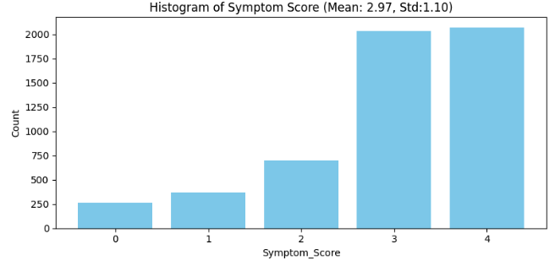
Figure 2: Histogram of Symptom_Score.

Figure 3: Boxplot of Exposure_Score by COVID status.


Figure 4: Model performance vs. regularization strength.


Figure 5: Top five logistic regression coefficients.


Figure 6: Confusion matrix.

References

Hemanth Harikrishnan. (2020). Symptoms and COVID Presence (May 2020 data). Kaggle.com. https://www.kaggle.com/datasets/hemanthhari/symptoms-and-covid-presence?resource=download

CDC. (2025, March 19). About COVID-19. COVID-19. https://www.cdc.gov/covid/about/index.html#:~:text=COVID%2D19%20most%20often%20causes,some%20people%20become%20severely%20ill.

Payong, A. (2025, March 20). Mastering Logistic Regression with Scikit-Learn: A Complete Guide. Digitalocean.com; DigitalOcean. https://www.digitalocean.com/community/tutorials/logistic-regression-with-scikit-learn?utm_source=chatgpt.com#logistic-regression-scikit-learn-example-binary-classification

Nagpal, A. (2022). L1 and L2 Regularization Methods, Explained | Built In. Built In. https://builtin.com/data-science/l2-regularization

GeeksforGeeks. (2025, May 23). Regularization in Machine Learning. GeeksforGeeks. https://www.geeksforgeeks.org/regularization-in-machine-learning/

Slater, N. (2016, November 15). Data Science Stack Exchange. Data Science Stack Exchange.
https://datascience.stackexchange.com/questions/15137/whats-the-best-way-to-tune-the-regularization-parameter-in-neural-nets

Overall Feedback
Overview and Objective — Level: L5
This section presents a compelling and medically grounded problem domain. COVID-19’s global impact is clearly summarized, using data from authoritative sources like the CDC and WHO to establish urgency and relevance. The challenge of false negatives in PCR testing and asymptomatic transmission provides a logical and well-supported rationale for applying predictive modeling, especially in triage and screening contexts.
The theoretical foundation of logistic regression is accurately explained. The model’s ability to estimate log-odds for binary outcomes and its assumptions—such as low multicollinearity among independent variables—are correctly identified and contextualized within the symptom-based questionnaire data. The model’s limitations are acknowledged without exaggeration.
The objective is clearly defined as a binary classification task to predict COVID-19 positivity using self-reported symptoms, exposures, and comorbidities. Prioritizing the minimization of false negatives demonstrates an understanding of the public health context. The plan includes conducting exploratory data analysis, engineering features, addressing class imbalance, and tuning the model—all appropriate steps aligned with best practices for logistic regression.
The tone remains professional, with focused attention on logistic regression and no deviation into unrelated modeling methods.
This section fully meets Level 5 expectations, showing strong alignment between problem relevance, algorithm selection, and the modeling objective.

Exploratory Analysis and Preprocessing — Level: L5
This section demonstrates comprehensive exploratory data analysis and a methodical approach to preprocessing. The dataset is accurately described as publicly available with 5,434 observations containing binary responses related to symptoms, exposures, and pre-existing conditions. Two features with zero variance are excluded, and the rationale for their removal is clearly justified to preserve meaningful information gain.
Multiple exploratory techniques are used to evaluate variable importance, including a correlation heatmap, a histogram of a composite Symptom_Score, and a boxplot comparing Exposure_Score by COVID status. These visualizations lead to insightful conclusions and support the creation of new, well-motivated features. This represents a strong example of EDA informing effective feature engineering.
Pairwise correlation checks are performed to confirm minimal multicollinearity, directly addressing one of logistic regression’s key assumptions. This step is often overlooked and indicates attention to model integrity.
Preprocessing steps are clear and appropriate: binary encoding of categorical data, construction of interaction features like Symptom_Exposure_Product, and retention of empirically validated features. Transformations are consistent with logistic regression's requirements, using additive and multiplicative combinations rather than nonlinear transformations.
All processes are model-appropriate, clearly explained, and avoid unnecessary complexity or techniques incompatible with logistic regression.
This section meets all Level 5 criteria for rigor, clarity, and alignment with the modeling task.

Model Fitting — Level: L5
The model fitting process is clearly structured and well executed. An 80/20 train-test split is used, which is suitable for the dataset size and modeling goals. The logistic regression model is implemented using scikit-learn with the liblinear solver, paired with L1 regularization—a technically sound choice for small to medium-sized binary classification problems.
Initial model training with default settings is followed by hyperparameter tuning. The selection of penalty='l1' and a regularization strength of C=0.1 through cross-validation demonstrates an effective approach to optimizing model performance. Adjusting the classification threshold from 0.5 to 0.35 to improve recall is a particularly thoughtful decision that aligns with the objective of minimizing false negatives in a public health context.
The modeling approach remains focused solely on logistic regression, and implementation details are reproducible through a referenced Google Colab notebook.
This section reflects a strong understanding of the interaction between regularization, interpretability, and recall, and fully satisfies Level 5 expectations.

Results and Interpretation — Level: L5
This section provides a well-articulated interpretation of the logistic regression model’s outputs. The role of coefficients in determining log-odds is explained clearly, and the relationship between coefficient sign and outcome likelihood is correctly described.
Engineered features such as Symptom_Score, Exposure_Score, and their interaction term are validated by their prominence among the top model coefficients, confirming their predictive utility. The insight that multicollinearity can lead to negative coefficients among correlated variables reflects an advanced grasp of regression behavior.
The model’s ability to achieve high recall, including zero false negatives as confirmed by the confusion matrix, is tied directly to the primary goal of improving COVID-19 screening reliability. The interpretation remains grounded in real-world application, connecting predictions to symptom patterns and exposure risk in a pandemic setting.
No unrelated methods are introduced, and technical explanations are framed in a way that would be understandable to both technical and applied audiences.
This section fully meets Level 5 standards through its clarity, application focus, and accuracy in interpreting model behavior in relation to the stated goal.

Conclusion — Level: L5
The conclusion effectively summarizes the project findings and maintains a direct connection to the original objective. It reiterates that logistic regression performed well in predicting COVID-19 positivity from symptom and exposure data, with an emphasis on recall in a public health screening context.
Key predictors—such as breathing difficulty, fever, dry cough, and exposure events—are appropriately highlighted, reinforcing the model’s alignment with clinical understanding. The impact of feature engineering, including Symptom_Score and Exposure_Score, is acknowledged as contributing to both model interpretability and performance.
An insightful reflection is included regarding the unexpected result that removing pre-existing condition variables reduced model performance. Rather than ignoring the outcome, this observation is incorporated into the overall analysis, adding nuance and depth.
The conclusion avoids unnecessary repetition of metrics and does not drift into unrelated model suggestions. It reaffirms that logistic regression was an appropriate and effective tool for the problem and summarizes the modeling effort with professionalism and focus.
This final section fully meets Level 5 expectations.

